Project Design Phase-II

Data Flow Diagram

|  |  |
| --- | --- |
| Date | 25 October 2022 |
| Team ID | PNT2022TMID33498 |
| Project Name | IOT based smart crop protection system for agriculture |
| Maximum Marks | 4 Marks |

# Data Flow Diagrams:

1. 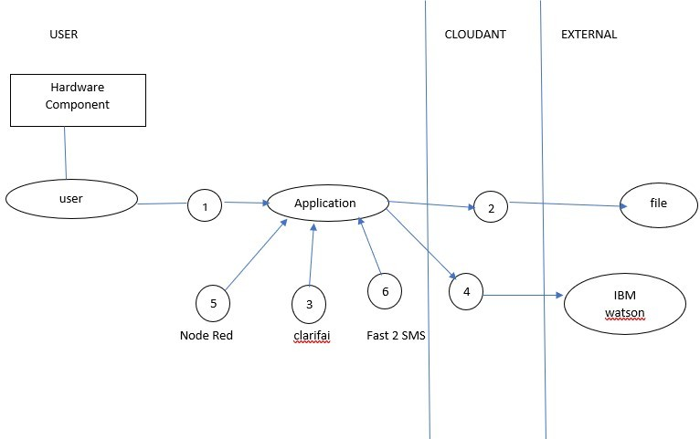 A Data Flow Diagram (DFD) is a visual representation of the information flows within a system.

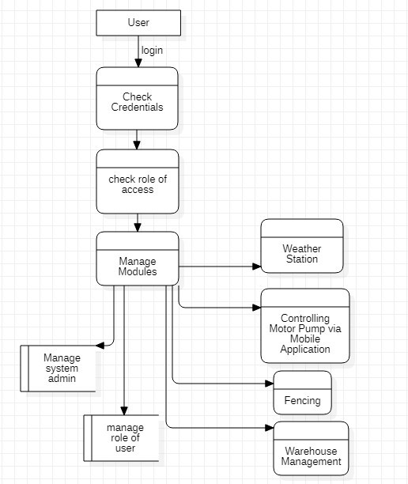

Example: DFD Level 0 (Industry Standard)

1. A neat and clear DFD can depict the right amount of the system requirement graphically. It shows how data enters and leaves the system, what changes the information, and where data is stored.